Directions: In small collaborative groups, work as a team to complete the following problems. Be sure that each member contributes to the discussion and has the chance to share their thoughts.
Algebra Connections:  Evaluate the expression when x = 5/8 and y = 3  1) 4 1/6 ÷ y  2) y ÷ x | Geometry Connections:  3) The area of the parallelogram below is 15/16 in². Find the height using the formula (area = b•h).  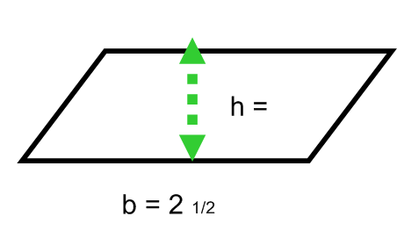
Word Problems:  4) Benton cut a 25 cm long ribbon into some pieces. Each piece was 1 2/3 cm long. How many pieces did she cut?  5) Making pasta requires boiling 6 ½ cups of water, but your measuring cup holds only ½ cup. How many times do you need to fill the measuring cup? | Debate  6) Review Milo’s work below and provide him with specific feedback.  