Algebra Connections:  1) If x = 3.52 and y = 6.4 then what is the value of xy?  2) What is the value of de + f if d = 9.1, e = 5.32 and f = 7.5? | Geometry Connections:  1) Use L x W to find the area of the rectangle.  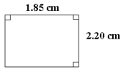  2) Use L x W x H to find the volume of the rectangular prism.  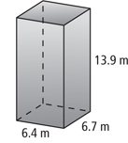
Word Problems:  1) The four swimmers on the American women’s 4x100 meter relay team went out to dinner at the Olive Garden. Each athlete ordered the Fettucine Alfredo, which cost 12.78 with tax and tip. What was the total bill?  2) Kevin jogged 6.2 miles each day for 28 straight days. How many miles did he jog in total? | Debate:  Hannah, Azulailet and Evanna are working on a problem in math class (8.52 x 6.7). Read the responses below and see who presents the best argument.  Hannah – I believe the answer is 57,084 because 852 times 67 is 57,084.  Azulailet – My answer of 57.084 is correct because I treated these like whole numbers when multiplying and calculated an answer of 57,084. I then counted the total number of digits to the right of the decimal (3) and moved my decimal in my answer three spaces to the left.  Evanna – My answer is similar to everyone’s but I got 570.84. When I multiplied the whole numbers I also got 57,084. I moved my decimal three jumps to the right.  Who is right?

