Learning Target | 6.NS.4 - Understand and use prime factorization and the relationships between factors to:  - Find the unique prime factorization for a whole number.  - Find the greatest common factor of two whole numbers less than or equal to 100.  - Use the greatest common factor and the distributive property to rewrite the sum of two whole numbers, each less than or equal to 100.  - Find the least common multiple of two whole numbers less than or equal to 12 to add and subtract fractions with unlike denominators.
Prerequisite Skills | RULES OF DIVISIBILITY  (Pick 2-3 from the choices below) |  |  |  |  | PRIME & COMPOSITE NUMBERS  (Pick 2-3 from the choices below)
 | Choice A – Read about the rules of divisibility from 2-12 |  |  |  |  | Choice A – Read about prime and composite numbers and then play this game to check your fluency
 | Choice B –. Look over the handout on the rules of divisibility |  |  |  |  | Choice B – Read how you can use the Sieve of Eratosthenes to see if a number is prime of composite
 | Choice C – Watch the instructional video (6:54) |  |  |  |  | Choice C – Watch the instructional video (5:30)
 | Choice D – Test your fluency on mathgames.com |  |  |  |  | Choice D – Practice finding prime numbers using the interactive Sieve of Eratosthenes
 | Choice E – Test yourself and play Quizizz |  |  |  |  | Choice E - Play the second Quizizz game to apply the 2, 3, 5, and 7 rule to see if these numbers are prime or composite.
Coaching Points | 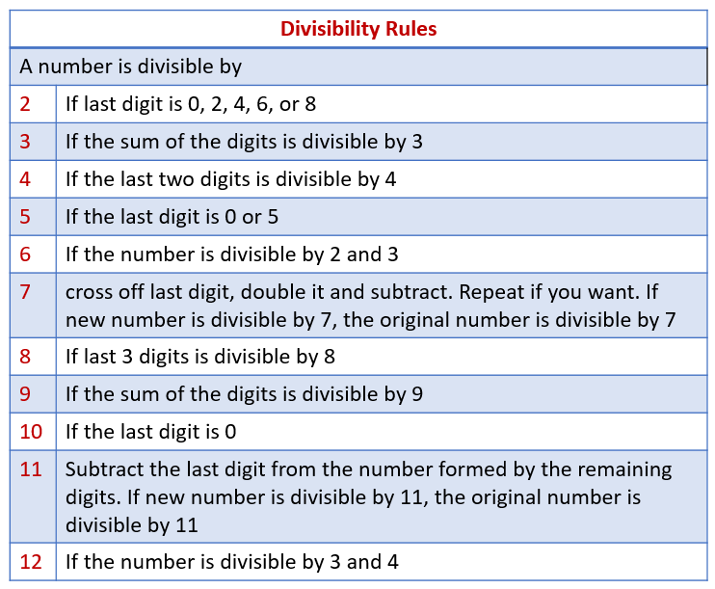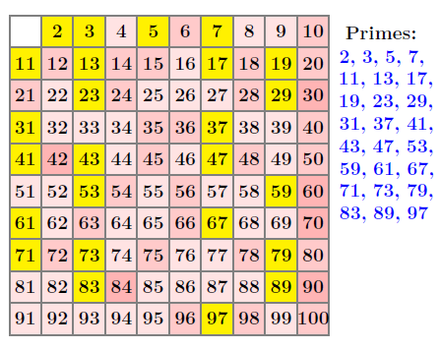  Sieve of Eratosthenes  - Circle 2 and mark out all multiples  - Circle 3 and mark out all multiples  - Circle 5 and mark out all multiples  - Circle 7 and mark out all multiples  - The rest of the numbers are prime  Big Idea: If you want to see if a number from 2-100 is prime, run the number through the 2, 3, 5, and 7 tests!
Prime Factorization | FACTOR TREES  (Pick 2-3 from the choices below) |  |  |  |  | LADDER  (Pick 2-3 from the choices below)
 | Choice A – Watch the video on factor trees and prime factorization (6:34) |  | Choice B – Read about factor trees and prime factorization here |  |  | Choice A – Read how to use the ladder method to find the prime factorization of a number |  |  | Choice B – Watch the video on using the ladder method to find the prime factorization of a number (4:28)
 | Choice C – Play the math game on factor trees |  | Choice D – Play the Math Goodies game on factor trees |  |  | Choice C – Test yourself with this online quiz using the ladder method |  |  | Choice D – Play the prime factorization IXL game using the ladder method
 | Choice E – Practice with this interactive tool. What does it mean if you can only make one array? Multiple arrays? |  | Choice F – Go to the Math Playground and use the factor tree to find the prime factorization of numbers |  |  | Choice E – Try this online quiz using the ladder method |  |  | Choice F – Find an expert in the classroom and get them to help you or visit the help desk
 | CW#1 – With a partner, answer the following questions one at a time. Be sure that you and your partner agree on each answer before moving to the next. |  |  |  |  | CW#2 – Roll the interactive dice to generate a number. With a partner, solve the question using the Rally Coach method on a sheet of notebook paper. Each person should solve 2-4 problems each.
 | HW#1 – Click here to access the copy of tonight’s homework. Be sure that you check your work with the answer key. |  |  |  |  | HW#2 – Open the HW document. Disregard the directions and instead solve using the ladder method. Be sure to check your answers using the answer key provided.
 | Summarizer – After each goal, Table Talk with people around you and discuss key points learned. Update your note guide using information from the mini lesson and from your table talk conversations.
Coaching Points | 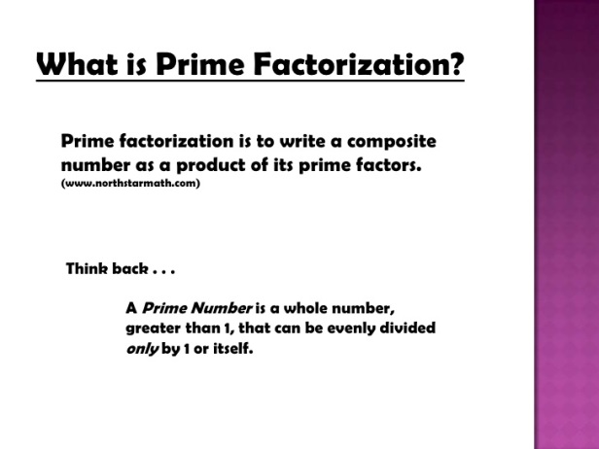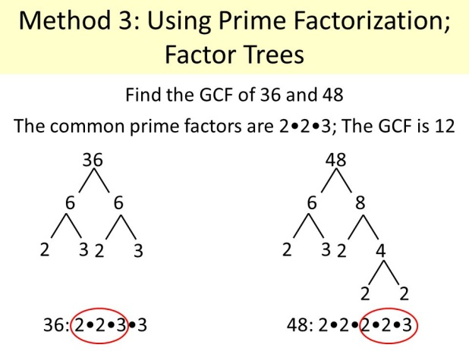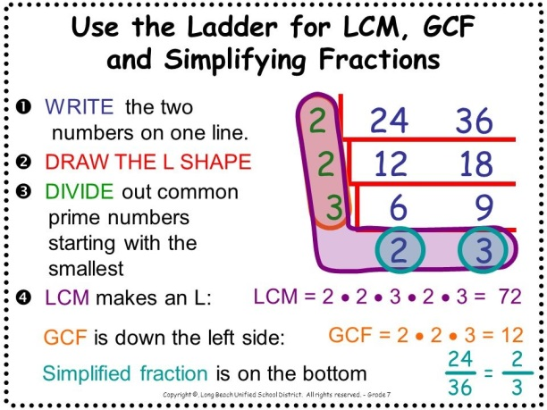
GCF & Distributive Property | GCF  (Pick any 2-3 from the choices below) |  |  |  | GCF & DISTRIBUTIVE PROPERTY  (Pick any 2-3 from the choices below)
 | Choice A – Watch the video on finding the GCF of two numbers using factor trees (1:36) | Choice B –.Watch the video on finding the GCF of two numbers using the ladder method (2:21) |  |  | Choice A – Watch this video to see an example of how to use the Distributive Property to write an equivalent expression (2:43) |  |  | Choice B – View the SlideShare presentation to see several practice problems. Page 2 has solutions.
 | Choice C – Select the level of difficulty as you find the GCF of two numbers by playing Fruit Splat | Choice D – Practice finding the GCF with Quizizz |  |  | Choice C – View the Slideplayer presentation |  |  | Choice D – Play this ClassK12 game for practice
 | Choice E – Build fluency by practicing with this game from Math Games | Choice F – Answer GCF questions to earn game time |  |  | Choice E – Play the Quizizz game on using the GCF and the Distributive Property to write equivalent expressions |  |  | Choice F – Play this IXL game to extend your understanding to writing equivalent algebraic expressions
 | CW#1 – Use the spinner to create your numbers (multiply 2 spins for a number). Find the GCF and compare your answers with your partner before moving on. |  |  |  | CW #1 – Use the attached document and answer key to practice using the GCF and the Distributive Property to rewrite numerical expressions. Be sure your answer matches your partner’s answer before moving forward.
 | HW#1 - Use the ladder method or prime factorization to answer the HW problems. Use the answer key to check your work. |  |  |  | HW #1 – Click here to practice using the GCF and the distributive property to write equivalent expressions. Be sure to check your answers before returning to class.
 | Summarizer – After each goal, Table Talk with people around you and discuss key points learned from the material that you chose. Update your note guide if necessary.
Coaching Points | 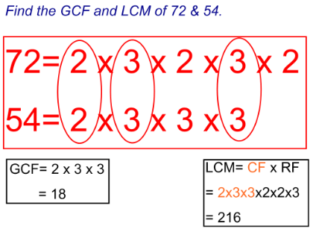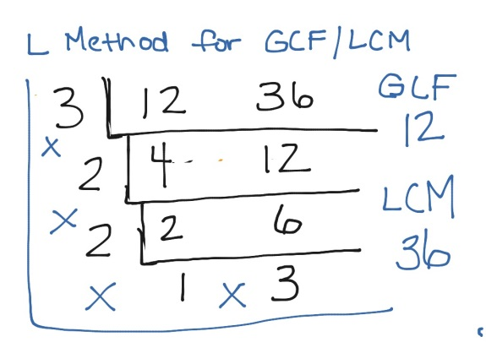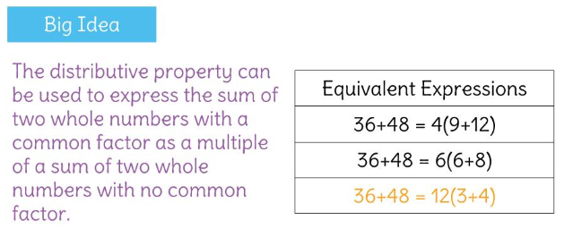
LCM & Real World | LCM  (Pick any 2-3 from the choices below) |  |  |  |  |  | GCF/LCM - REAL WORLD  (Pick any 2-3 from the choices below)
 | Choice A – Watch this video for help finding the LCM using prime factorization (4:40) |  |  | Choice B – See how to use the ladder method to find the LCM of two numbers with this instructional video (2:21) |  |  | Choice A – Watch this video for help determining the difference between GCF and LCM (2:45) |  |  | Choice B – Here is a longer video to help you to determine if word problems are looking for the GCF or the LCM (9:55)
 | Choice C – Click here to play Quizizz and practice finding the LCM |  |  | Choice D – Get some skill and drill practice playing MathGames |  |  | Choice C – Play MathGames to help you practice identifying real world questions using GCF and LCM |  |  | Choice D – Attempt the Khan Academy practice problems
 | Choice E – Play the Snowball Fight game as you practice finding the LCM of 2 numbers |  |  | Choice F – Additional online practice finding the LCM |  |  | Choice E – Practice finding the GCF and LCM by playing IXL |  |  | Choice F – Practice identifying GCF and LCM word problems as you play Quizizz
 | CW#1 – Use the Rally Coach method to take turns solving these classwork problems. An answer key is provided to assist your team. |  |  |  |  |  | CW#1 - In pairs, pick any 5 problems to solve. Look for clues to help you identify whether each question requires you to find the GCF or LCM. Your team must agree on the answer before moving to the next question.
 | HW#1 – Pick any 8 problems to solve using the ladder method or prime factorization. Check your work using the answer key provided. |  |  |  |  |  | HW#1 –Click to open tonight’s homework. Look for key words and determine if each word problem is a GCF or LCM question. From there, solve each.
 | Summarizer – After each goal, Table Talk with people around you and discuss key points learned from the material that you chose. Update your note guide if necessary.
Coaching Points | 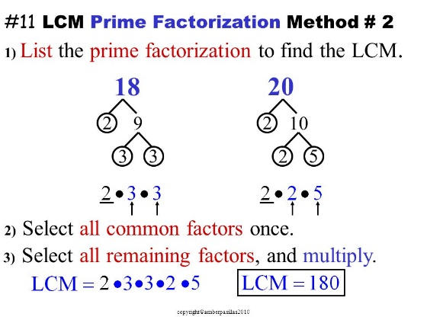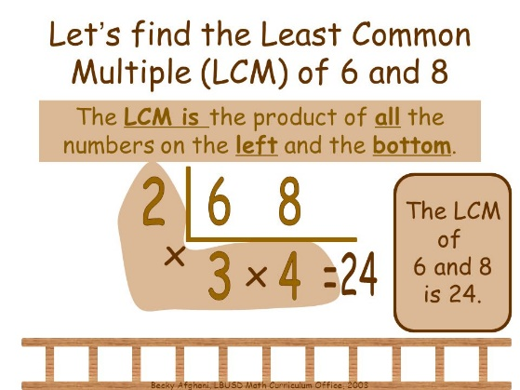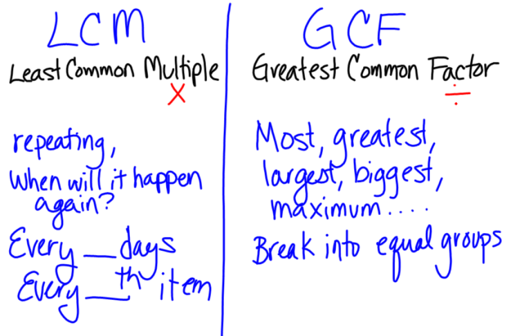

Add & Subtract Fractions | ADD FRACTIONS  (Pick any 2-3 from the choices below) |  | SUBTRACT FRACTIONS  (Pick any 2-3 from the choices below)
 | Choice A – Watch the Khan Academy video on adding fractions with unlike denominators (2:32) | Choice B – Watch this video to see the Vedic method for adding fractions (5:13) | Choice A – View this short video on subtracting fractions with unlike denominators | Choice B – Watch this video to see the Vedic method for subtracting numbers with unlike denominators (6:31)
 | Choice C – Play Math Games to practice adding fractions with unlike denominators | Choice D –Play the Math Playground game to practice adding fractions with unlike denominators | Choice C – Play Fruit Splat to build fluency with subtracting fractions (Level 2a or higher) | Choice D – Practice subtracting fractions with IXL
 | Choice E – Play Football Fractions and complete the pass to answer questions on adding fractions | Choice F – Practice adding fractions with unlike denominators as you play Quizizz | Choice E – Play Math Games to practice adding fractions with unlike denominators | Choice F – Practice subtracting fractions with unlike denominators as you play Quizizz
 | CW#1 - With a partner, select 4-6 word problems to solve. Compare your answers with a partner and refer to the answer key if necessary. To move ahead, your answers must match. |  | CW #1 – With a partner, select 4-6 word problems to solve. Compare your answers with a partner and refer to the answer key if necessary. To move ahead, your answers must match.
 | HW#1 – Click to open up the homework problems. Pick any 8 problems to solve and check your answers before returning to class. |  | HW#1 – Select 8 problems from the skill and drill set. Use the answer key to check your work.
 | Summarizer – After each goal, Table Talk with people around you and discuss key points learned from the material that you chose. Update your note guide if necessary.
Coaching Points | 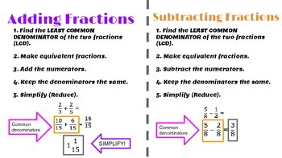  ANCIENT VEDIC METHOD – VERTICALLY & CROSSWISE  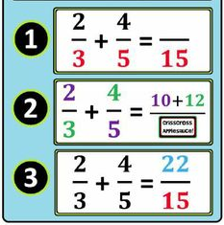

Quiz Preparations

 | Step 1 – Review your personal data tracking form and determine which topics you should spend extra time studying. | Step 2 – Based on your self-identified weaknesses, look over your note guide. | Step 3 – Go to the Number Sense Quizizz Collections. Select games based on your weaknesses and play the game until you reach content mastery (> 80%).

