Directions: In small collaborative groups, work as a team to complete the following problems. Be sure that each member contributes to the discussion and has the chance to share their thoughts.
Algebra Connections:  Create equivalent expressions by using the GCF as a factor of the expression.  1) 6m + 12  2) 7m + 28 | Geometry Connections:  3) Find the GCF and then write the area of the rectangle as product of two factors.  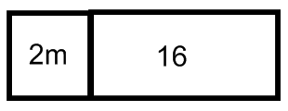  4) Find the GCF and then write the area of the rectangle as product of two factors.  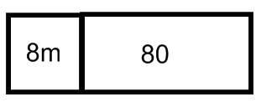
Real World Word Problems:  5) Cal and Sal each spent $5.00 on a souvenir cup and $4.00 on a hot dog at the W-S Dash baseball game. The total money spent by the two students can be written as an expression 2(4 + 5). Write an equivalent expression for the money the two spent. | Debate:  6) Review the problem and determine who used the GCF to create an equivalent expression.  24 + 12 + 15  Isabella – I decided the GCF was 2. This means an equivalent expression would be 2(12 + 6 + 15)  Paige – I used 3 as my GCF and rewrote the problem to become 3(8 + 4 + 5)  Louisa – My GCF was 1 and my equivalent expression is 1(24 + 12 + 15)  Which student presented the best argument and it correct?

