Golf Course Design/ Round of Golf
6.NS.5 – Intro to Integers

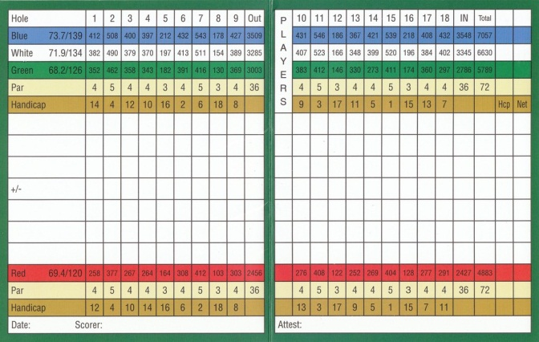

Directions for course design:
1) Design a course
2) Place flags at the pins of each hole
3) Write an integer (-13 through 13) on each flag

Directions to play:
1) Each hole is a par 5
2) Flip cards until you hit the integer value on the flag
3) Each card represents a stroke
4) Record your score as a plus/negative integer
5) Play 18 holes
6) Compare your scorecard to your opponent to declare the winner (lowest score wins)

