Directions – Plot the points to create a polygon. Use the correct formula to determine the area and/or perimeter of each.
1. Find the area/perimeter of the polygon whose vertices are (-3, -1), (-3, -6), (0, -6), and (0, -1)  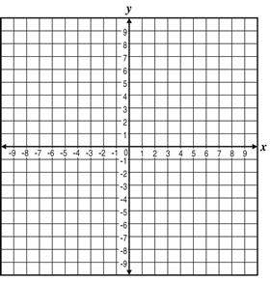  Area = _______ Perimeter = _______ | 2. Find the area/perimeter of the polygon whose vertices are (0, 1), (-8, 4), (0, 4), and (-8, 1)  Area = _______ Perimeter = _______
3. Find the area of the polygon whose vertices are (-2, 3), (-2, -1), and (-6, -1)  Area = _______ | 4. Find the area of the polygon whose vertices are (7, 0), (0, 0), and (0, -7)  Area = _______
5. Find the area of the polygon whose vertices are (-6, 10), (-4, 6), (2, 10), and (4, 6)  Area = _______ | 6. Find the area of the polygon whose vertices are (2, 4), (0, 1), (-5, 4), and (-7, 1)  Area = _______
CHALLENGE PROBLEM – OPTION #1  Find the area of the irregular polygon whose vertices are (-5, -9), (-8, -9), (-1, -2), and (-8, -2)  Area = _______ | 8. CHALLENGE PROBLEM – OPTION #2  Find the area of the irregular polygon whose vertices are (-4, -2), (-6, 2), (-6, 6), (-2, 6), and (-2, 2). Connect points as you plot new points.  Area = _______

