Lesson 15: Locating Ordered Pairs on the Coordinate Plane

Classwork
Example 1: Extending the Axes Beyond Zero
The point below represents zero on the number line. Draw a number line to the right starting at zero. Then, follow directions as provided by the teacher.

Example 2: Components of the Coordinate Plane
All points on the coordinate plane are described with reference to the origin. What is the origin, and what are its coordinates?

To describe locations of points in the coordinate plane, we use of numbers. Order is important, so on the coordinate plane, we use the form$($ $)$. The first coordinate represents the point’s location from zero on the -axis, and the second coordinate represents the point’s location from zero on the -axis.
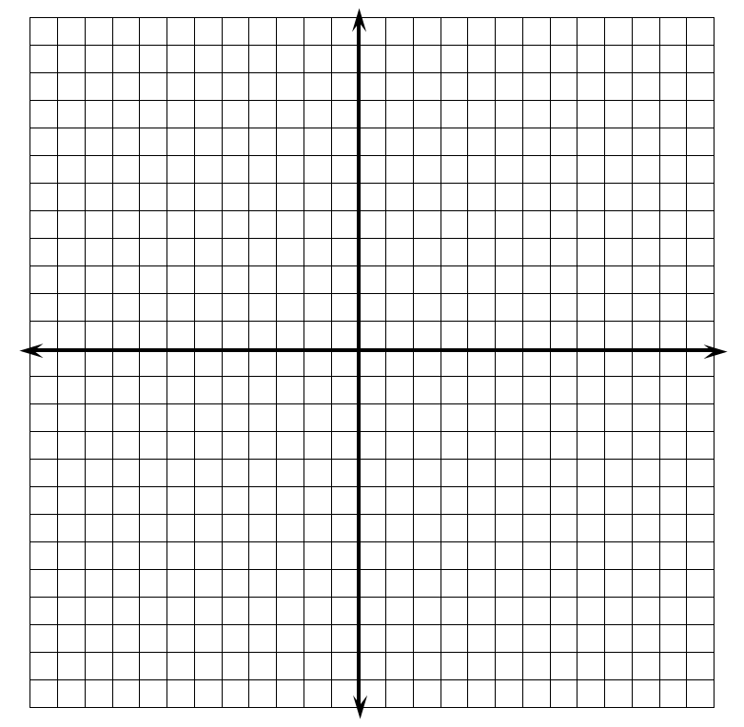
Exercises 1–3
- Use the coordinate plane below to answer parts (a)–(c).
  - Graph at least five points on the $x$-axis, and label their coordinates.

  - What do the coordinates of your points have in common?

  - What must be true about any point that lies on the
$x$-axis? Explain.

- Use the coordinate plane to answer parts (a)–(c).
  - Graph at least five points on the $y$-axis, and label their coordinates.

  - What do the coordinates of your points have in common?

  - What must be true about any point that lies on the $y$-axis? Explain.

- If the origin is the only point with $0$ for both coordinates, what must be true about the origin?

Example 3: Quadrants of the Coordinate Plane

Exercises 4–6
- Locate and label each point described by the ordered pairs below. Indicate which of the quadrants the points lie in.
  - $\left(7, 2\right)$

  - $\left(3,-4\right)$

  - $\left(1,-5\right)$

  - $\left(-3, 8\right)$

  - $\left(-2,-1\right)$

- Write the coordinates of at least one other point in each of the four quadrants.
  - Quadrant I

  - Quadrant II

  - Quadrant III

  - Quadrant IV

- Do you see any similarities in the points within each quadrant? Explain your reasoning.

Lesson Summary
- The $x$-axis and $y$-axis of the coordinate plane are number lines that intersect at zero on each number line.
- The axes partition the coordinate plane into four quadrants.
- Points in the coordinate plane lie either on an axis or in one of the four quadrants.

Problem Set

- Name the quadrant in which each of the points lies. If the point does not lie in a quadrant, specify which axis the point lies on.
  - $\left(-2, 5\right)$
  - $\left(8,-4\right)$
  - $\left(-1,-8\right)$
  - $\left(9.2, 7\right)$
  - $\left(0,-4\right)$

- Jackie claims that points with the same $x$- and $y$-coordinates must lie in Quadrant I or Quadrant III. Do you agree or disagree? Explain your answer.

- Locate and label each set of points on the coordinate plane. Describe similarities of the ordered pairs in each set, and describe the points on the plane.
  - $\left\{\left(-2, 5\right), \left(-2, 2\right), \left(-2, 7\right), \left(-2, -3\right), \left(-2, -0.8\right)\right\}$
  - $\left\{\left(-9, 9\right), \left(-4, 4\right), \left(-2, 2\right), \left(1,-1\right), \left(3,-3\right), \left(0, 0\right)\right\}$
  - $\left\{\left(-7,-8\right), \left(5,-8\right), \left(0,-8\right), \left(10,-8\right), \left(-3,-8\right)\right\}$

- Locate and label at least five points on the coordinate plane that have an $x$-coordinate of $6$.
  - What is true of the $y$-coordinates below the
$x$-axis?
  - What is true of the $y$-coordinates above the
$x$-axis?
  - What must be true of the$y$-coordinates on the
$x$-axis?

