Lesson 14: Ordered Pairs

Classwork
Example 1: The Order in Ordered Pairs

The first number of an ordered pair is called the .

The second number of an ordered pair is called the .

Example 2: Using Ordered Pairs to Name Locations
Describe how the ordered pair is being used in your scenario. Indicate what defines the first coordinate and what defines the second coordinate in your scenario.

Exercises
The first coordinates of the ordered pairs represent the numbers on the line labeled $x,$and the second coordinates represent the numbers on the line labeled $y$.
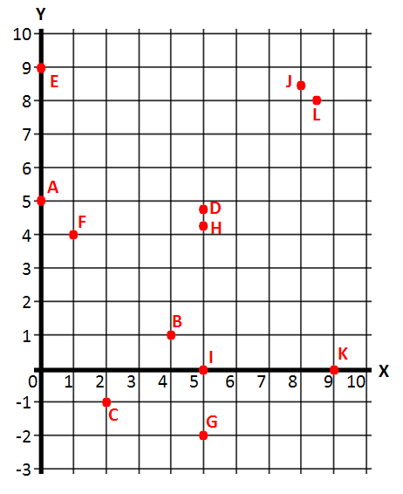
- Name the letter from the grid below that corresponds with each ordered pair of numbers below.
 | $$\left(1, 4\right)$$ |  | $$\left(0, 5\right)$$
 | $$\left(4, 1\right)$$ |  | $$\left(8.5, 8\right)$$
 | $$\left(5, -2\right)$$ |  | $$\left(5, 4.2\right)$$
 | $$\left(2, -1\right)$$ |  | $$\left(0, 9\right)$$

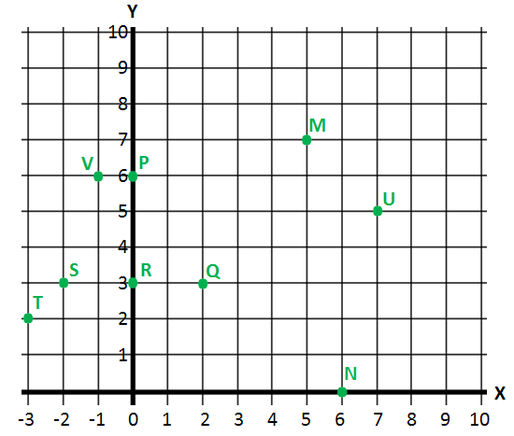
- List the ordered pair of numbers that corresponds with each letter from the grid below.
 | Point $M$ |  | Point $S$
 | Point $N$ |  | Point $T$
 | Point $P$ |  | Point $U$
 | Point $Q$ |  | Point $V$
 | Point $R$

Lesson Summary
- The order of numbers in an ordered pair is important because the ordered pair should describe one location in the coordinate plane.
- The first number (called the first coordinate) describes a location using the horizontal direction.
- The second number (called the second coordinate) describes a location using the vertical direction.

Problem Set

- Use the set of ordered pairs below to answer each question.
$$\{(4, 20), (8, 4), (2, 3), (15, 3), (6, 15), (6, 30), (1, 5), (6, 18), (0, 3)\}$$
  - Write the ordered pair(s) whose first and second coordinate have a greatest common factor of $3$.
  - Write the ordered pair(s) whose first coordinate is a factor of its second coordinate.
  - Write the ordered pair(s) whose second coordinate is a prime number.

- Write ordered pairs that represent the location of points $A$, $B$, $C$, and $D$, where the first coordinate represents the horizontal direction, and the second coordinate represents the vertical direction.
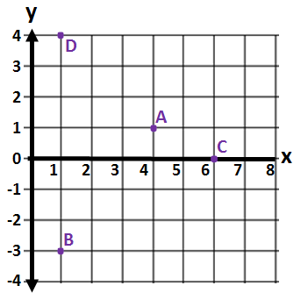

Extension:
- Write ordered pairs of integers that satisfy the criteria in each part below. Remember that the origin is the point whose coordinates are $\left(0, 0\right)$. When possible, give ordered pairs such that (i) both coordinates are positive, (ii) both coordinates are negative, and (iii) the coordinates have opposite signs in either order.
  - These points’ vertical distance from the origin is twice their horizontal distance.
  - These points’ horizontal distance from the origin is two units more than the vertical distance.
  - These points’ horizontal and vertical distances from the origin are equal, but only one coordinate is positive.

