Lesson 16: Symmetry in the Coordinate Plane

Classwork
Opening Exercise
Give an example of two opposite numbers, and describe where the numbers lie on the number line. How are opposite numbers similar, and how are they different?

Example 1: Extending Opposite Numbers to the Coordinate Plane
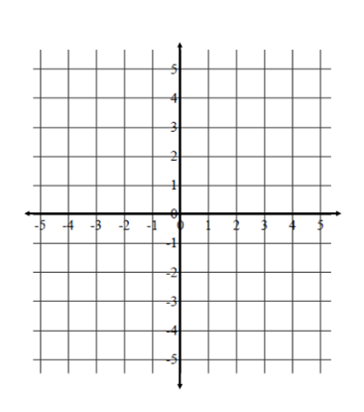
Extending Opposite Numbers to the Coordinates of
Points on the Coordinate Plane
Locate and label your points on the coordinate plane to the right. For each given pair of points in the table below, record your observations and conjectures in the appropriate cell. Pay attention to the absolute values of the coordinates and where the points lie in reference to each axis.
 | $\left(3,4\right)$ and $\left(-3,4\right)$ | $\left(3,4\right)$ and $\left(3,-4\right)$ | $\left(3,4\right)$ and $\left(-3,-4\right)$
Similarities of Coordinates
Differences of Coordinates
Similarities in
Location
Differences in
Location
Relationship Between Coordinates and Location on the Plane

Exercises
In each column, write the coordinates of the points that are related to the given point by the criteria listed in the first column of the table. Point $S\left(5, 3\right)$ has been reflected over the $x$- and $y$-axes for you as a guide, and its images are shown on the coordinate plane. Use the coordinate grid to help you locate each point and its corresponding coordinates.
Given Point: | $$S\left(5,3\right)$$ | $$\left(-2,4\right)$$ | $$\left(3,-2\right)$$ | $$\left(-1,-5\right)$$ | S  M  L  A  $$x$$  $$y$$
The given point is reflected across the $x$-axis.
The given point is reflected across the $y$-axis.
The given point is reflected first across the $x$-axis and then across the $y$-axis.
The given point is reflected first across the $y$-axis and then across the $x$-axis.

- When the coordinates of two points are $(x,y)$ and $(-x,y)$, what line of symmetry do the points share? Explain.

- When the coordinates of two points are$(x,y)$ and $(x,-y)$, what line of symmetry do the points share? Explain.

Examples 2–3: Navigating the Coordinate Plane
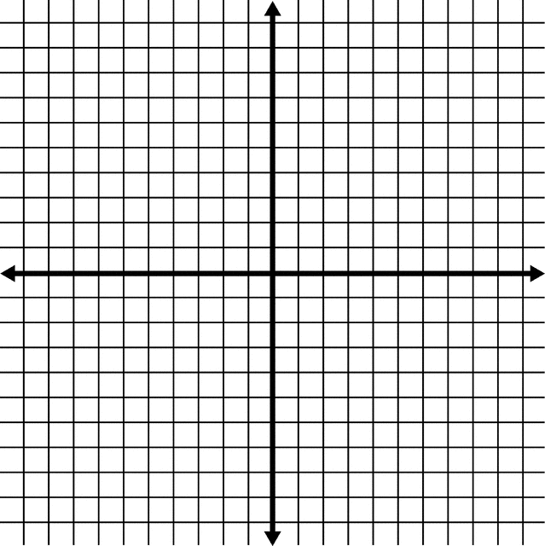
Problem Set

- Locate a point in Quadrant IV of the coordinate plane. Label the point $A$, and write its ordered pair next to it.
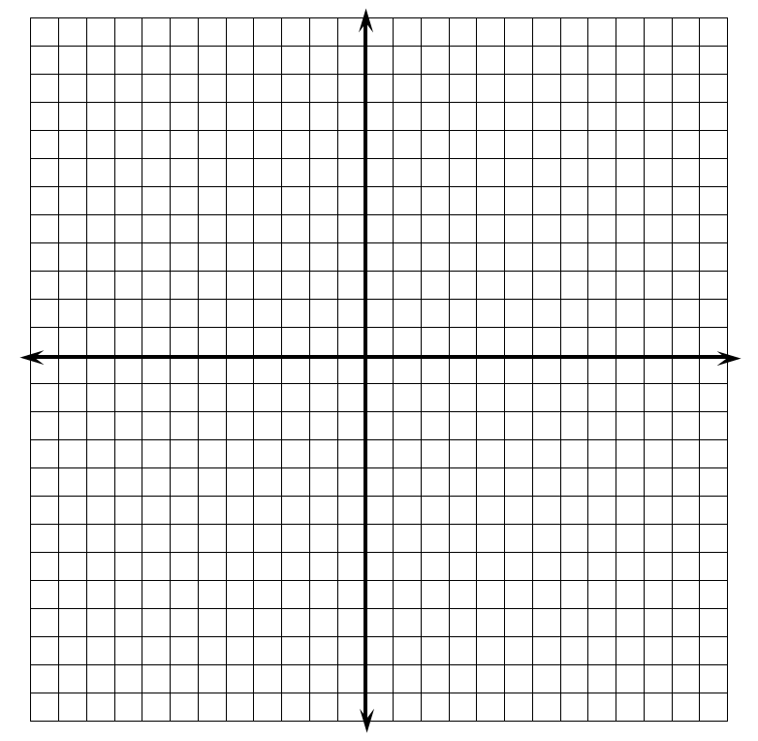
  - Reflect point $A$ over an axis so that its image is in Quadrant III. Label the image $B$, and write its ordered pair next to it. Which axis did you reflect over? What is the only difference in the ordered pairs of points $A$ and $B$?
  - Reflect point $B$ over an axis so that its image is in Quadrant II. Label the image $C$, and write its ordered pair next to it. Which axis did you reflect over? What is the only difference in the ordered pairs of points $B$ and $C$? How does the ordered pair of point $C$ relate to the ordered pair of point $A$?
  - Reflect point $C$ over an axis so that its image is in Quadrant I. Label the image $D$, and write its ordered pair next to it. Which axis did you reflect over? How does the ordered pair for point $D$ compare to the ordered pair for point $C$? How does the ordered pair for point $D$ compare to points $A$ and $B$?

- Bobbie listened to her teacher’s directions and navigated from the point $\left(-1, 0\right)$ to $\left(5,-3\right)$. She knows that she has the correct answer, but she forgot part of the teacher’s directions. Her teacher’s directions included the following:
“Move $7$ units down, reflect about the ? -axis, move up $4$ units, and then move right $4$ units.”
Help Bobbie determine the missing axis in the directions, and explain your answer.

